SVN Usages

Version 1.0
Date 28/10/10

Copyright notice
Copyright © 2010, Cognizione consulting & solutions Pvt Ltd
All rights reserved.

These materials are confidential and proprietary to Cognizione consulting & solutions pvt
ltd/its licensors and no part of these materials should be reproduced, published, transmitted
or distributed in any form or by any means, electronic, mechanical, photocopying, recording or
otherwise, or stored in any information storage or retrieval system of any nature nor should the
materials be disclosed to third parties without the prior express written authorization of
Cognizione consulting & solutions Pvt ltd/its licensors
Revision history

Doc No: | Version no. | Change reference no. | Author | Published date | Sections changed | Description of changes
 | 1.0 |  | Dikshit | 28/10/10 |  | Base Document

Contents

Purpose of the document 4
Scope of the document 4
Desired outcome 4
Targeted recipient 4
Prerequisite 4
Basic SVN activities 4
Creation of a Repository 5
Starting the SVN Server 6
Import 7
Using NetBeans 7
Using Tortoise 11
Other Usages 13

Purpose of the document

This document describes the following

- Usage of different SVN operations like checkout, commit etc.

Scope of the document

This document only explains various usages of SVN for different day to day operations. It doesn’t explain the following points, some of which are covered in a different document.

- Installation and configuration of SVN environment.
- Different commands for operations like import, commit etc as all these are accomplished visually mostly through NetBeans IDE and some through Tortoise SVN Client.

Desired outcome

- Proper usage of SVN by the development team.

Targeted recipient

- All members of the development team

Prerequisite

Recipients are expected to have knowledge on the following which are covered in the presentation “Introduction To SVN”.

- Basic idea of a version controlling system.
- Basic idea about SVN and its different operations.

Basic SVN activities

The first step after setting up of the svn environment is creation of the “Repository” which stores different projects that has to be version controlled.
A project which has to be version controlled through svn is first put under a svn repository through a process called import. Once a project is imported into the svn repository then basically the following activities are performed at different stages.

- Checkout to local folder.
- Commit changes to repository.
- Update changes done by others.
- Conflict resolution.
- Creation of a new development branch.
- Merging of a branch with the main line.

Creation of a Repository

To create a repository follow the steps mentioned below

- Create a folder by any name , say “Repository”, in the machine that you want as SVN Server.
- Right the folder just created → Tortoise SVN → Create Repository here , as shown in the figure below

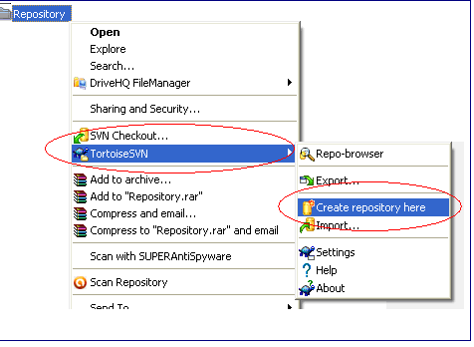

Figure 1 : Creating a repository

- Successful creation of SVN Server will give the following message
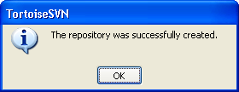

Figure 2 : - Message indicating successful creation of SVN repository

- Open the folder and verify that the following folder structure as shown below is created inside the Repository folder

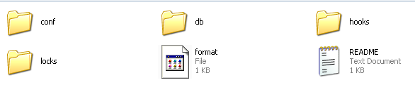

Figure 3 : File and Folder structure inside the repository

Starting the SVN Server

To use the functionalities of SVN server it must be started. There are two ways to start the svn server viz. – Through command prompt or as a Windows Service. We follow the former approach and hence the second approach is not mentioned.

To start svn server from the command prompt follow the steps given below

- Open command prompt in the svn server machine.
- Change directory to the drive in which you have created the “Repository” , as mentioned in the above section. E.g if it is in “D:” drive then cd to “D:” drive.
- Type the following command , and press enter.

svnserve –daemon

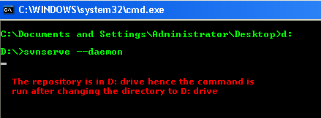

Figure 4 : Starting the SVN Server

- To stop the server , press “CTRL-C”.

Import

Importing a project means to put it under the SVN repository for version controlling. The following sections describes how to import a project using both NetBeans and Tortoise SVN client.

Using NetBeans

To import a project using NetBeans follow the steps mentioned below

- Right Click the project → Versioning → Import into Subversion Repository.

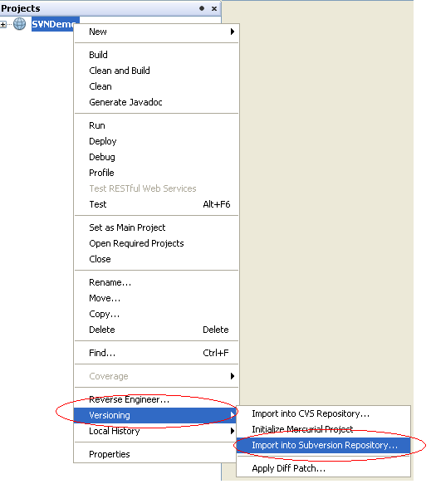
Figure 5 : Importing a project using NetBeans

- This will give the following screen
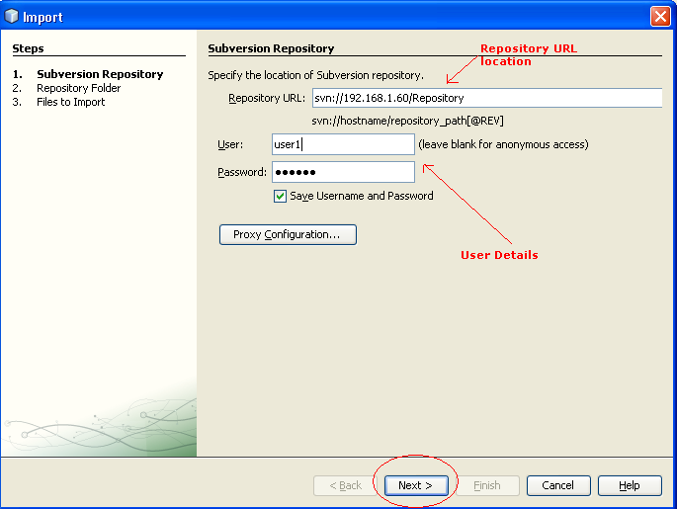

Figure 6 : Importing a project

- Click on “Next” button which will bring up the following screen where you have to specify a message in the “Specify the Message” text field.
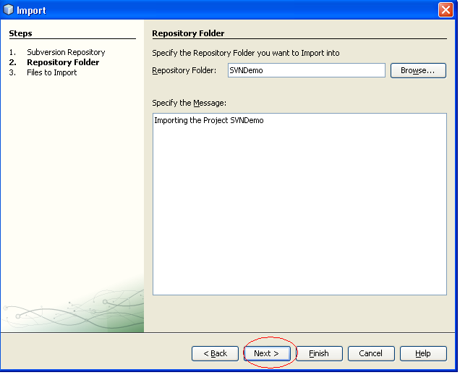
Figure 7 : - Specifying message before importing.

- Click on “Next” as encircled in the figure 7.
- This will bring up the following screen.

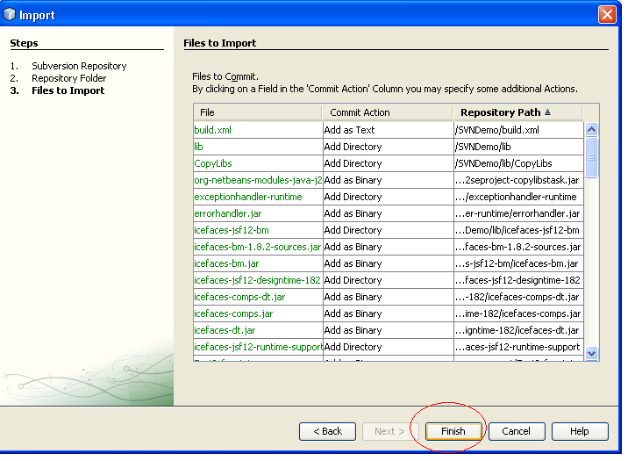
Figure 8 : Final screnn before uploading

- Click on “Finish” to start importing.

- While importing the output window of NetBeans will show the following messages

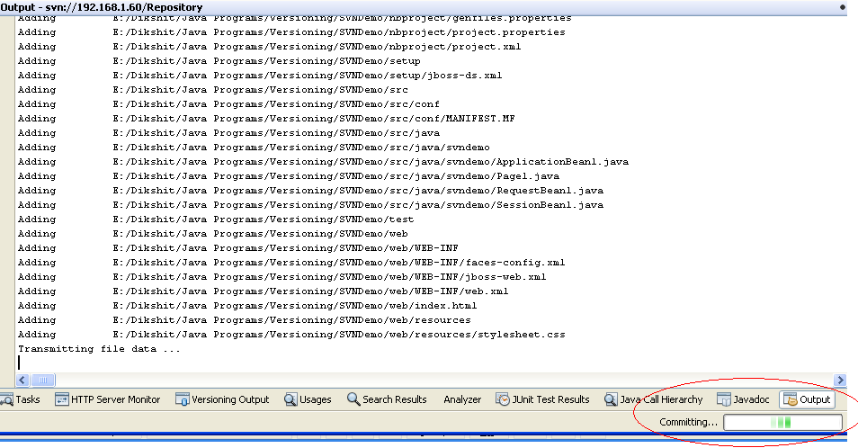

Figure 9 : Importing data

Using Tortoise

- Right Click the folder containing the project → Tortoise SVN → Import, as shown in fig 10.
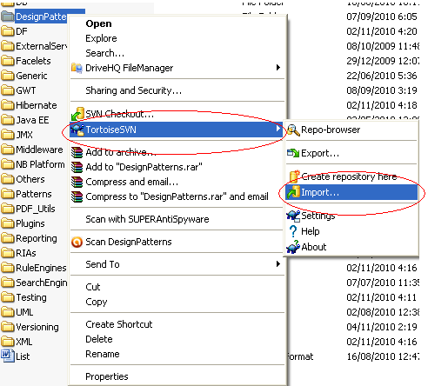

Figure 10 : Importing using Tortoise

- This will bring the following screen 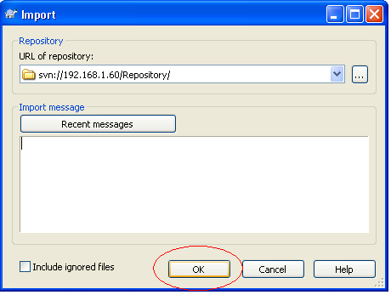
Figure 11 : Importing
- Click on “OK” to import.

- While importing you will see the following screen giving the status of import.

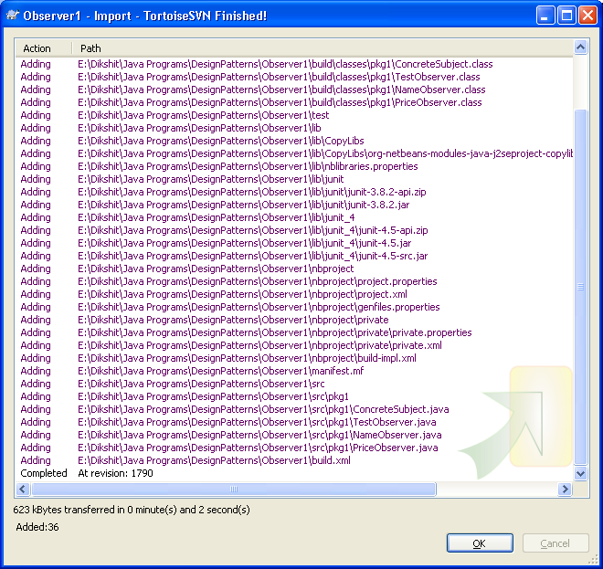

Figure 12 : Status during importing

Other Usages
For other usages like Commit, Update etc, refer to the “Source Code Configuration.ppt” file.

